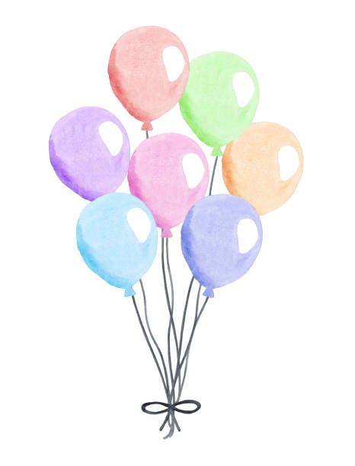
IS IT YOUR BIRTHDAY?!

Come Celebrate with Us at Strike It Up Artistic Center!

Pick Any of the Following Party Themes:

Gymnastics
Karaoke/Musical Theater
Dance
(Hip Hop, Jazz, Ballet)
Art and Crafts
Fit & Funk

Each party receives thirty minutes of instruction, time for presents, a pizza party, and, if you desire, thirty minutes of Bouncy Hose Time!

Also included is pizza/pop, paper products, and decorations.

$25.00/child General Party (No Bouncy House)
$28.00/Child Premium Party (Bouncy House Included)
$30.00/Child Specialty Party (Unique Theme and Bouncy House)

The Birthday Child is FREE!

10 Children are required to hold a party. The required 10 does not include the birthday child.

For more information, call Strike It Up at (315) 524-5330.
Located at 2045 Route 104, Ontario NY, 14519.

