Music Production and Sound Engineering Class
Create your own original music!
Calling all aspiring Singer/Songwriters, Recording Artists, and Producers!!
In this class you will:
- Write, compose, perform, record, produce, and publish original music
- Learn about the tools of the music industry
Join us Tuesdays to create and produce your songs in the SIU professional recording studio!
Sound Engineering 101 Tuesdays @ 4:45
Sound Engineering 102 Tuesdays @ 5:30
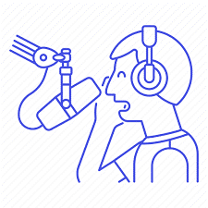

Call Strike it Up to register (315) 524-5330 or visit siuac.org

